**Scala Assignment 13**

**Task 1**

Given a list of strings - List[String] (“alpha”, “gamma”, “omega”, “zeta”, “beta”)

- Find count of all strings with length 4.

- Convert the list of string to a list of integers, where each string is mapped to its

corresponding length.

- Find count of all strings which contain alphabet ‘m’.

- Find the count of all strings which start with the alphabet ‘a’.

**Solution**

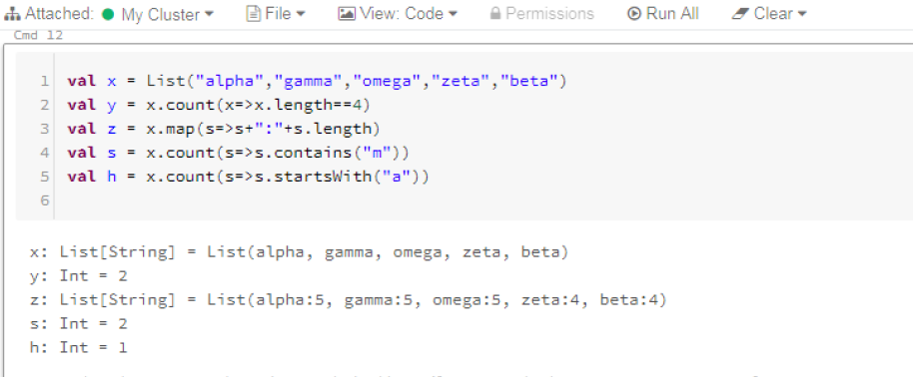

**Task 2**

Create a list of tuples, where the 1st element of the tuple is an int and the second

element is a string.

Example - ((1, ‘alpha’), (2, ‘beta’), (3, ‘gamma’), (4, ‘zeta’), (5, ‘omega’))

- For the above list, print the numbers where the corresponding string length is 4.

- find the average of all numbers, where the corresponding string contains alphabet ‘m’

or alphabet ‘z’.

**Solution :**

